DSA0136OBJECT ORIENTED PROGRAMMING WITH C++

Name: ch. vamsi krishna

Reg:192110482

__________________________________________________

1. WAP in C++ to calculate the bonus of the employee. The class – master derived information from admin and account class and they both derived the information from person class. Create a base class and all derived class with necessary function.

PROGRAM-

#include <iostream>

using namespace std;

int emp_id,bp,ded;

float hra,da,ta,gs,ns;

char empname[20];

class master

{

public:

void getdata()

{

cout<<"\nenter employee id and employee name:";

cin>>emp_id>>empname;

}

};

class admin:public master

{

public:

void getdata1()

{

cout<<"\nenter the basic pay:";

cin>>bp;

}

};

class account:public master

{

public:

void getdata2()

{

hra=bp*0.15;

ta=bp*0.20;

da=bp*1;

cout<<"\nhome rent allowance is:"<<hra;

cout<<"\nthe travelling allowance is:"<<ta;

cout<<"\nthe d allowance is:"<<da;

}

};

class person:public admin,public account

{

public:

void getdata3()

{

cout<<"\nenter deduction :";

cin>>ded;

gs=bp+hra+ta+da;

ns=gs-ded;

cout<<"\nthe gross salary is:"<<gs;

cout<<"\nthe net salary is:"<<ns;

}

};

int main()

{

master m;

m.getdata();

person p;

p.getdata1();

p.getdata2();

p.getdata3();

}

OUTPUT-

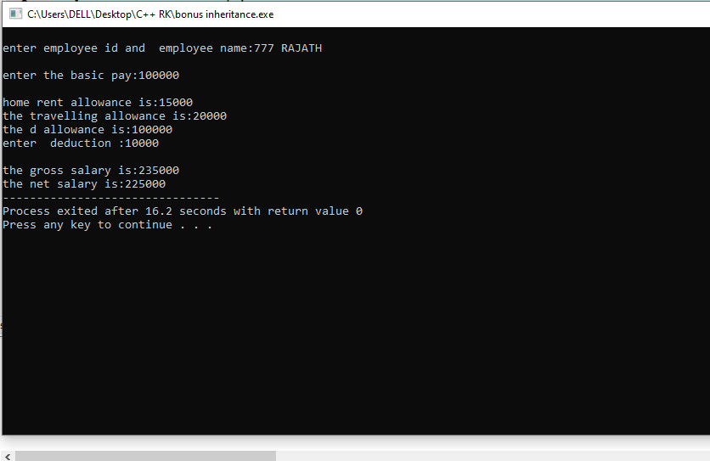

1. WAP IN C++ to demonstrate multiple inheritance by creating a class cuboid which is derived from class rectangle and shape. Calculate the area and volume.

PROGRAM-

#include<iostream>

using namespace std;

int l,b,h,a;

class rectangle

{

public:

void getdata()

{

cout<<"enter length and breadth:";

cin>>l>>b;

}

};

class shape

{

public:

void getdata1()

{

cout<<"\nenter the height:";

cin>>h;

}

};

class cuboid:public rectangle, public shape

{

public:

void getdata3()

{

a=l*b*h;

cout<<"\nthe volume of the cuboid is:"<<a;

}

};

int main()

{

cuboid c;

c.getdata();

c.getdata1();

c.getdata3();

return 0;

}

OUTPUT-

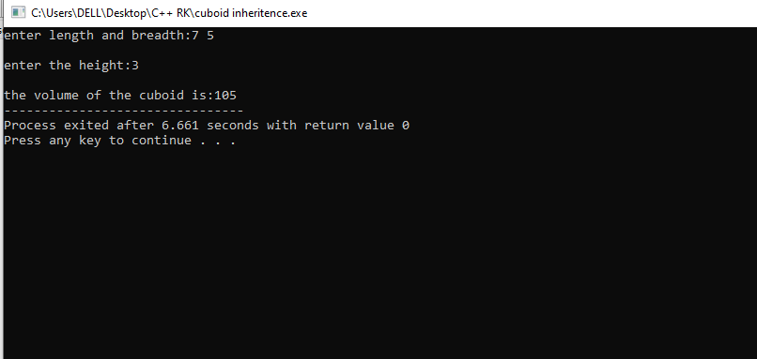

1. WAP in C++ to find sum and product of 2 no.s using single inheritance

PROGRAM-

#include<iostream>

using namespace std;

class sum

{

int a,b;

public:

void sum1()

{

cout<<"\nenter 2 values:";

cin>>a>>b;

cout<<"\nthe addition of 2 no.s is"<<a+b;

}

};

class product:public sum

{

int x,y;

public:

void prod()

{

cout<<"\nenter 2 values:";

cin>>x>>y;

cout<<"\nthe product of no.s is"<<x*y;

}

};

int main()

{

product p;

p.prod();

p.sum1();

return 0;

}

OUTPUT-

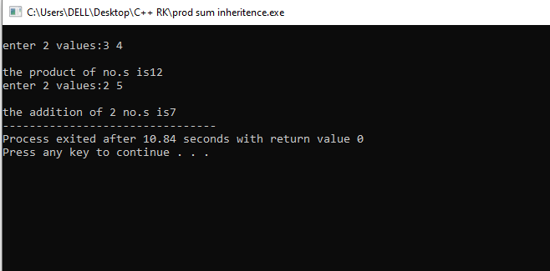

1. WAP in C++ to create class student which stores the roll number, class-test stores the marks of 3 subjects and class result stores the result.

The class result inherits the details of the marks obtained in the test,roll number and result of student through derived class.

PROGRAM-

#include<iostream>

using namespace std;

int m1,m2,m3;

class student

{

public:

int roll_no;

void getdata()

{

cout<<"\nenter the roll number:";

cin>>roll_no;

}

};

class test

{

public:

void getdata1()

{

cout<<"\nenter the marks:";

cin>>m1>>m2>>m3;

}

};

class result:public student,public test

{

public:

void getdata2()

{

int result;

result=m1+m2+m3;

cout<<"\nthe result is:"<<result;

}

};

int main()

{

result r;

r.getdata();

r.getdata1();

r.getdata2();

return 0;

}

OUTPUT-

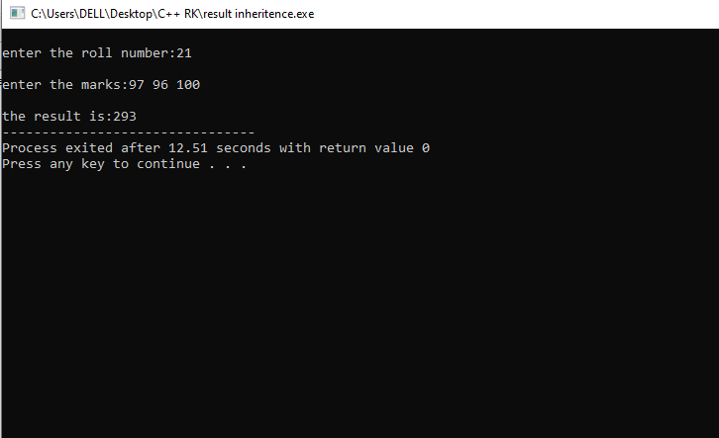

1. WAP in C++ to create class fruits to calculate the no. of apples and mangoes present in the basket and print the no. of each fruits in the basket and total no. of fruits in the basket.

PROGRAM-

#include<iostream>

using namespace std;

int x,y;

class apple

{

public:

void app()

{

cout<<"\nenter the no. of apples:";

cin>>x;

}

};

class mango

{

public:

void man()

{

cout<<"\nenter the no. of mangoes:";

cin>>y;

}

};

class fruits:public apple,public mango

{

public:

void fruit()

{

int total=x+y;

cout<<"\nthe total no. of fruits in the basket are:"<<total;

}

};

int main()

{

fruits f;

f.app();

f.man();

f.fruit();

return 0;

}

OUTPUT-

